WQ.129/2026

WRITTEN QUESTION TO THE MINISTER FOR SUSTAINABLE ECONOMIC DEVELOPMENT
BY DEPUTY T.A. COLES OF ST. HELIER SOUTH
QUESTION SUBMITTED ON MONDAY 6th JULY 2026
ANSWER TO BE TABLED ON MONDAY 13th JULY 2026

Question

“Will the Minister advise –

- whether records are maintained of water rescues, resuscitation incidents (including CPR) and first-aid treatments undertaken by RNLI lifeguards on Jersey beaches and, if so, provide a breakdown by beach location for each of the last five years and;
- how many water rescues, resuscitation incidents (including CPR) and first-aid treatments have occurred at Havre des Pas bathing pool in each of the last five years, and whether this information has been used to assess the need for lifeguard provision at the site?”

Answer

I am sure that all members would acknowledge the important role that RNLI lifeguards play in keeping Jersey’s wonderful beaches safe for both islanders and visitors. In recent years, they have sought to increase the number of lifeguards who are Jersey residents, which we welcome.

a) This data is held by the RNLI and has been provided in the tables below.
b) The Havre des Pas Lido is managed by a private operator and is not included within the Government’s beach-lifeguarding contract with the RNLI. Lifeguarding provision is therefore provided at the discretion of the private operator.

Nevertheless, the I&E Department do hold historic data on incidents over the last five years which is provided below:

Havre Des Pas
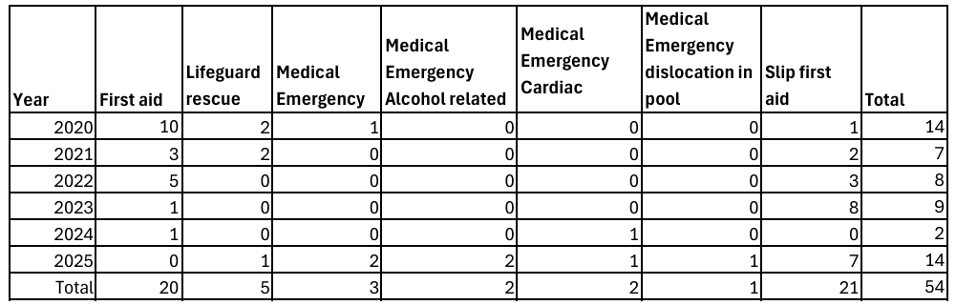

2025
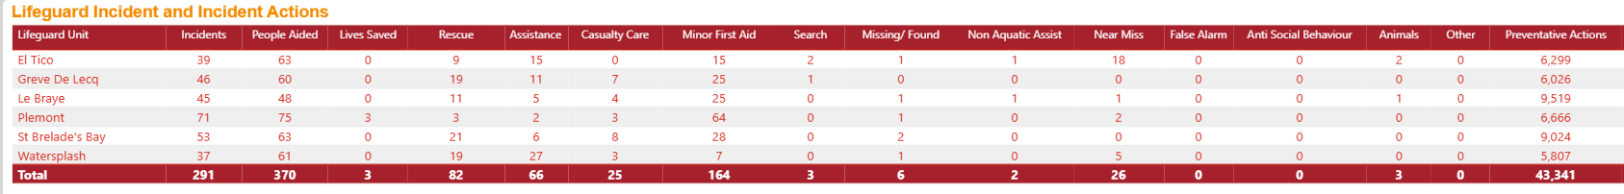

2024
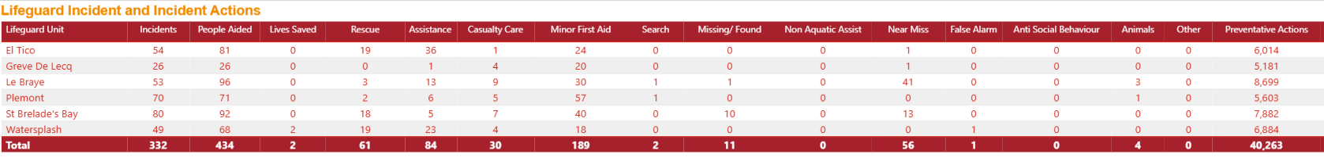

2023
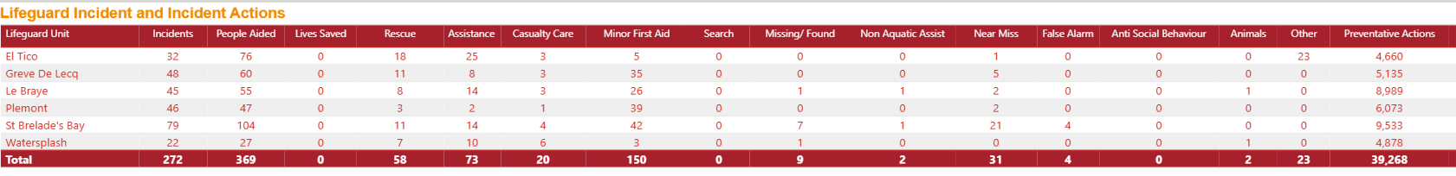

2022
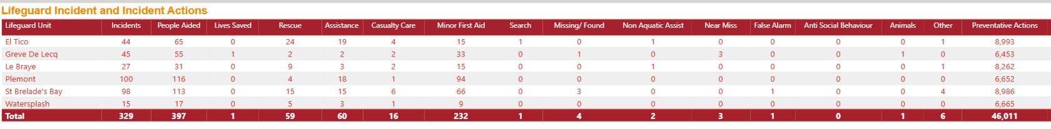

2021
